**DMFabric**

**A Blockchain Application for Disaster Management**

**A POC submitted for**

**IBM Call for Code**

**By**

**Atul Sarpotdar under Team CodeMind**

[**atul.sarpotdar@capgemini.com**](mailto:atul.sarpotdar@capgemini.com)

Aug 27, 2018

**Objective**

World has seen many crisis situations because of various kinds of natural disasters where victims have to leave their houses, find necessary services to survive such as food, shelter, medical, transport. They often do not have necessary funds to avail these kind of services in these situations.

Governments, multiple organizations, volunteers provide their help or generally have necessary will to provide their help during these natural disasters but lack of proper channel limit these efforts. At high level below are issues they face while providing a helping hand –

* Lack of secure environment where all parties are verified and accountable
* Lack of trusted & transparent channel to prevent mismanagement of funds & services (so that there are no conflict scenarios with respect to these)
* Lack of necessary ecosystem where existing enterprise systems & channels are integrated esp. for service providers
* Lack of the real-time resident tracking information based on which rescue operations can be initiated.

The objective is to develop and establish an environment addressing above mentioned and other significant issues for overall better Disaster Management

**Solution**

Solution is to build necessary ecosystem/network using technology which covers combined use of multiple technology platforms available today.

**Mobile & Web Application Platform** to provide single channel to access this ecosystem

**Blockchain Platform**

* It creates a secure, resilient, traceable, trusted and transparent business network for Disaster Management
* It facilitates effective communication and on time response for participants/ organizations during crisis situation**.**
* With Blockchain’s shared distributed ledger all transactions are logged on to the network.
* Service providers can connect to Blockchain network using their existing eco systems for publishing their services and communicate with other participants.
* Thus it provides a platform or ecosystem for disaster management and brings governance in system.
* Blockchain’s key characteristics help to establish a trusted & transparent environment for business where transactions can be settled faster and efficiently.

**Cloud Platform** for providing high availability, more security and scalability for this ecosystem

**DMFabric Application**

DMFabric Application will utilize features of these platforms in combination to provide the technical solution we are looking for. It creates a secure, resilient, traceable and transparent business network for Disaster Management using Hyperledger Fabric (a blockchain framework implementation and one of the Hyperledger projects hosted by The Linux Foundation)

**Participants in this network –**

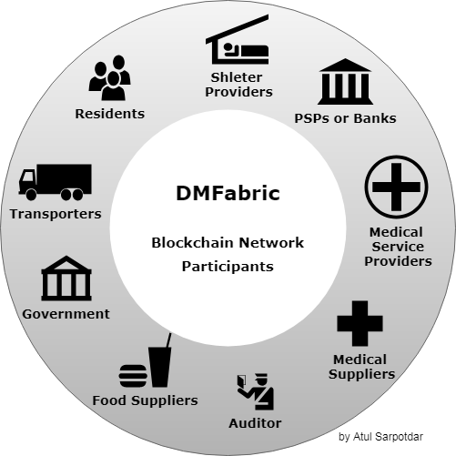

* Government (Different Departments)
* Auditor
* Bank or PSPs (Payment Service Providers)
* Shelters
* Food suppliers
* Transporters
* Medical suppliers
* Medical Service Providers
* Residents

**Key Features –**

**Front End Mobile & Web Application and Service API Interfaces** - The DMFabric network provides one platform to connect the residents, service providers and funds providers ( their existing enterprise systems ) using APIs

**Payment Wallet** – Once registered, system will activate a payment wallet for affected residents/victims. The fund providers and Government & Banks can add money to these wallets directly to provide more transparency in fund distribution. Then residents can use this wallet money to avail any paid services as and when needed.

This again provides an alternative and efficient way for payment during crisis situations instead of using cash or cards. **A payment mechanism using VPA (Virtual Payment Address), UPI (**Unified Payments Interface**) and MPIN can be used for these payment wallets which will be convenient and secure.**

**Single View –** The system will provide a single view for residents (who actually know ground reality than the Government) & service providers to help each other by connecting them in more structured way. They don’t need to rely on various social media platforms for information they need

**Architecture**

Below is reference architecture for DMFabric showing primary systems & components -

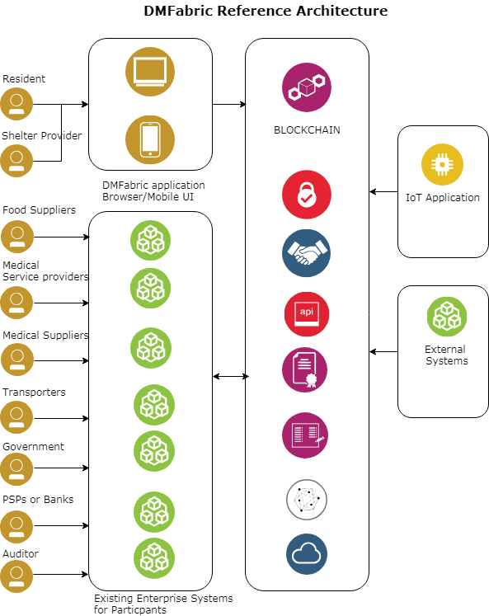

**DMFabric Network**

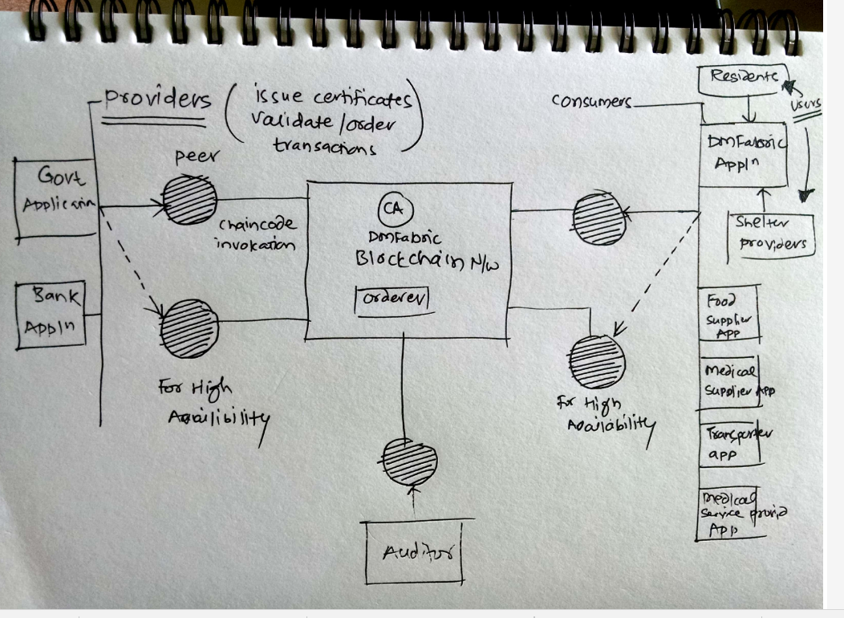

**Technology & IBM services**

**IBM Blockchain Platform**

Hyperledger Composer – provides abstraction layer for Hyperledger Fabric (which leverages **Javascript**)

Hyperledger Fabric - Hyperledger Fabric allows components, such as consensus and membership services, to be plug-and-play. Hyperledger Fabric leverages container technology to host smart contracts called “chaincode” that comprise the application logic of the system

**IBM Bluemix** – to host blockchain

**IBM Push Notifications -** to popup alerts on the mobile & web

**IBM Mobile Foundation** - to provide offline capabilities for residents to get information even if they are not connected to the internet

**IBM App ID –** toprovide the facility to login to the application using the social media identity (Google, Facebook)

**IBM API Management -** to provide secure access to the APIs exposed by the application.

**IBM Cloudant – A distributed database based on Apache CouchDB** for storing documents etc.

**JAVA SDK/ Node for APIs**

**IBM IoT Platform** – can be used for leverage services for Internet of Things but this is not in scope currently for this poc.

The system will keep evolving and may use other technologies in future.

**Use Case Scenarios –**

Use Case Scenarios are covered in **separate document**

**DM Fabric Environment Set Up**

A developer tutorial is given at - <https://hyperledger.github.io/composer/v0.19/tutorials/developer-tutorial.html>

<https://ibm-blockchain.github.io/platform-deployment/>

Define Business network (Assets, Participants) using **Hyperledger composer modelling language** and write transaction logic

**Start the fabric network**

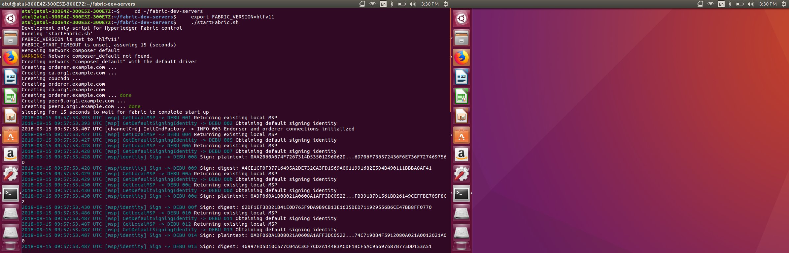

**Create Admin Network card**

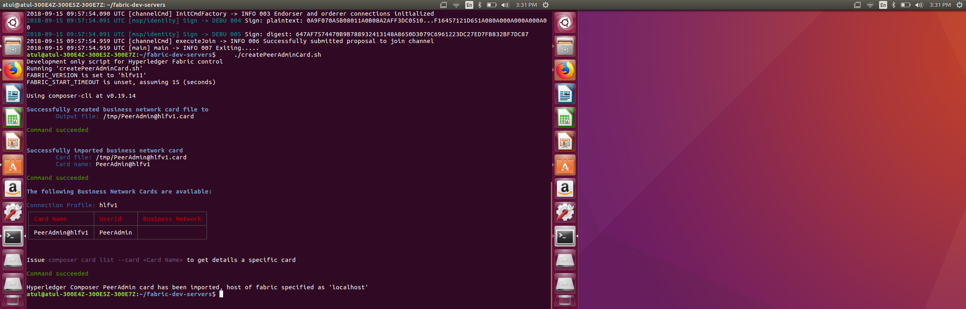

**Import card then deploy Hyperledeger Business Network Archive BNA file (file is attached separately) and start the network**

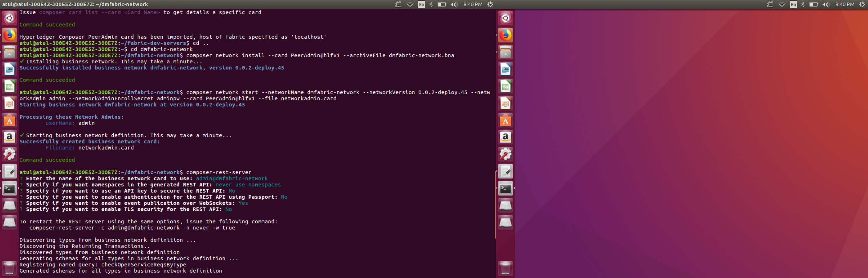

Composer REST server

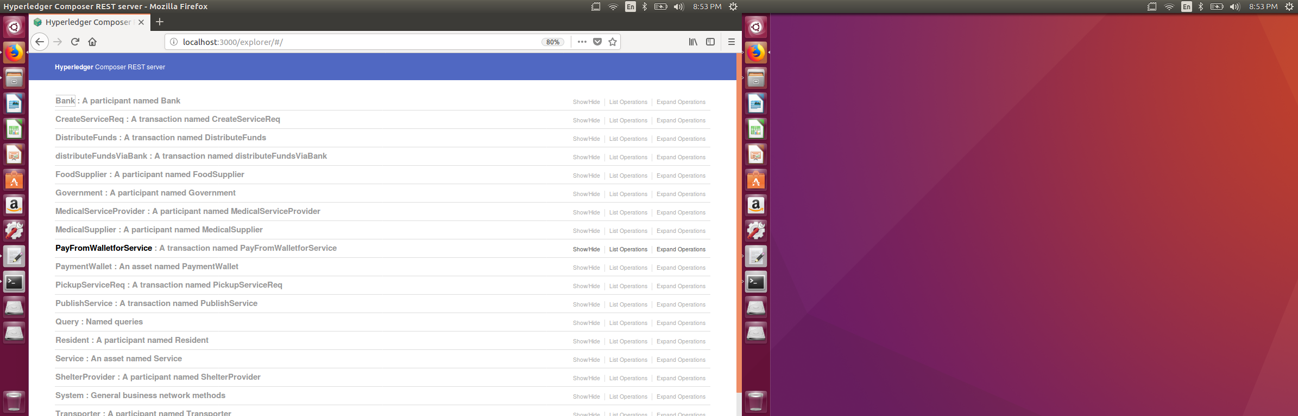

REST API details and code are covered separately in **DMFabric Demo.ppt**

Application URL on IBM Cloud –

<https://blockchain-starter.ng.bluemix.net/network/n50de031f85bd4cd78886e131904d4f08/overview>

**User Interface**

Here are some sample screenshots for app UI & web UI **skeleton**. Integrated with REST services this becomes DMFabric UI interface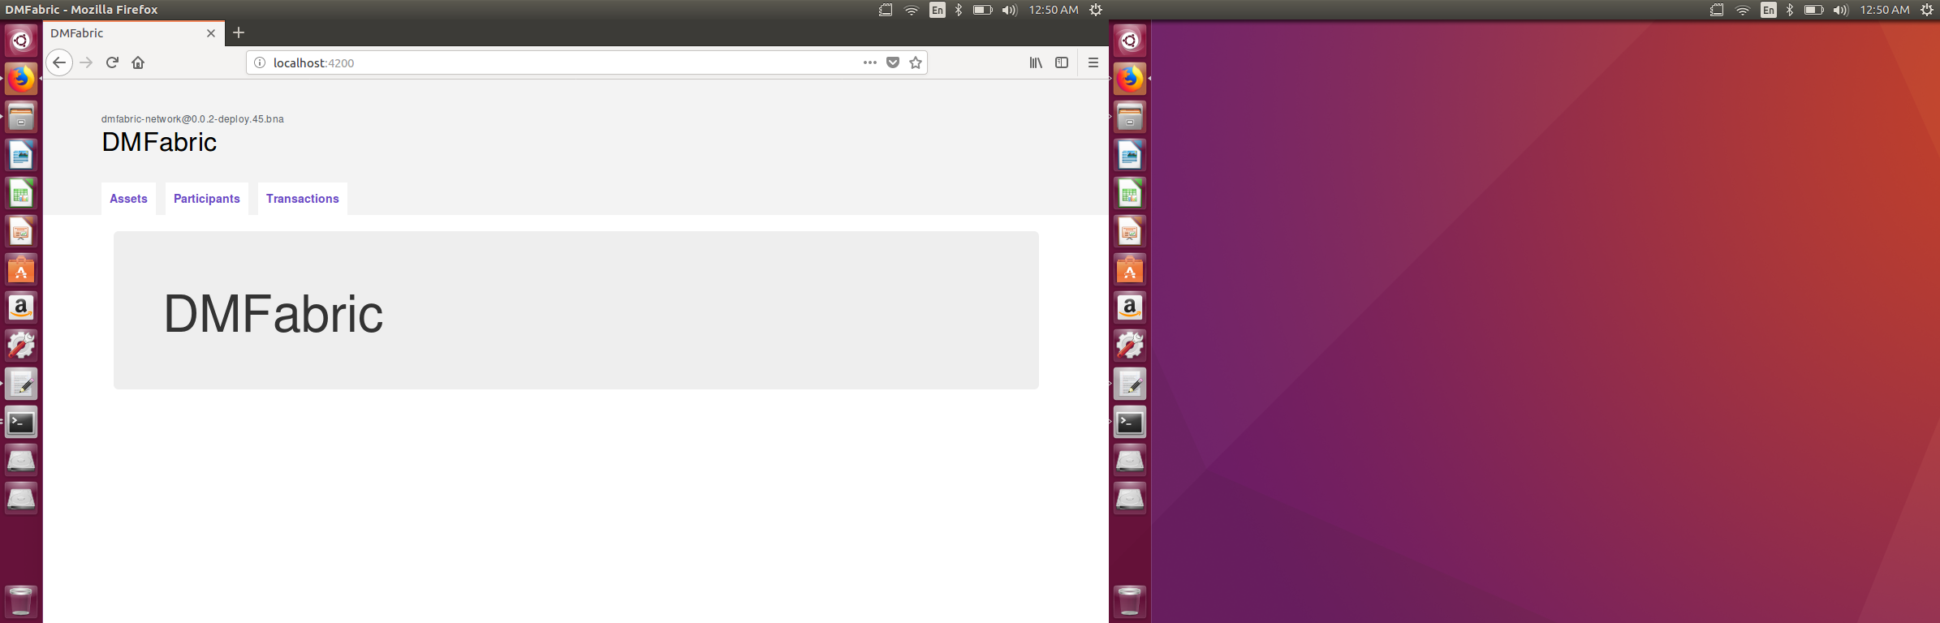

Resident Registration:

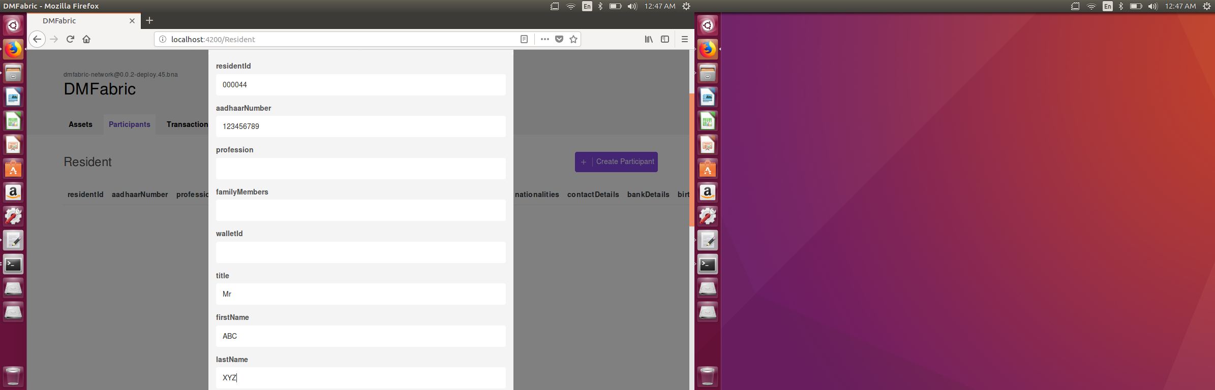

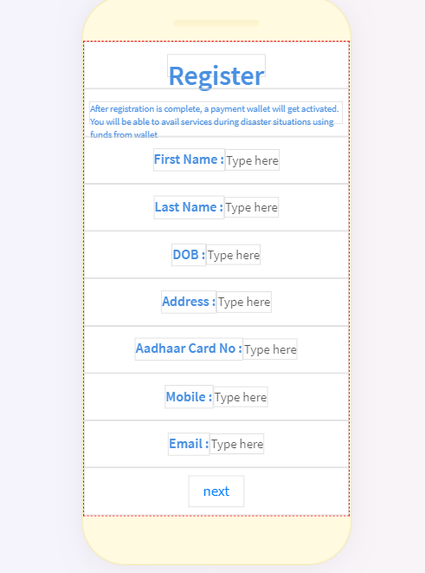

Service Provider:

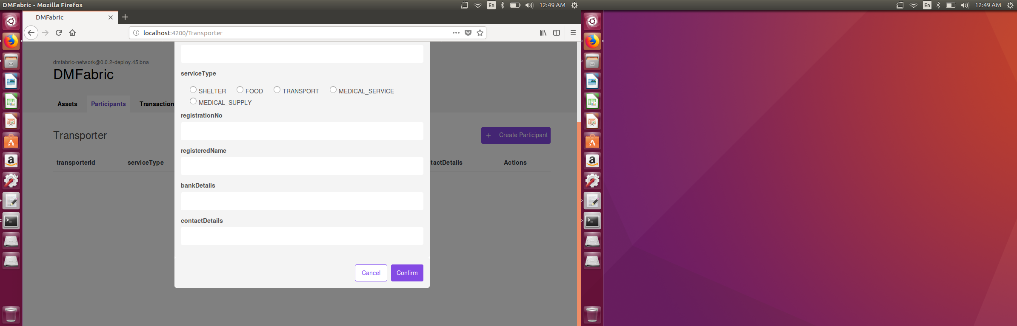

Service

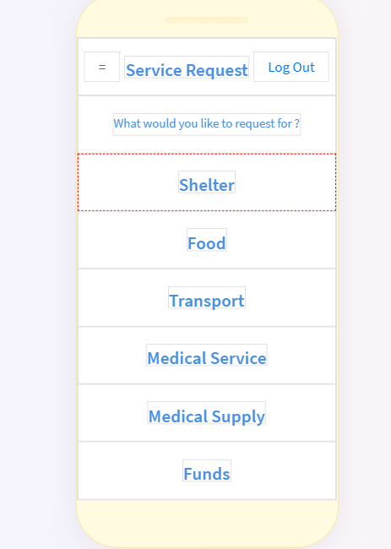

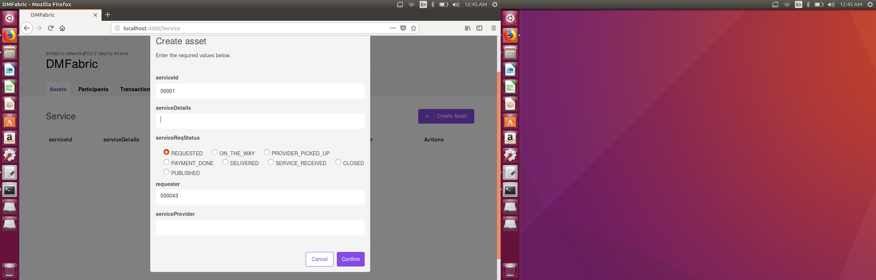

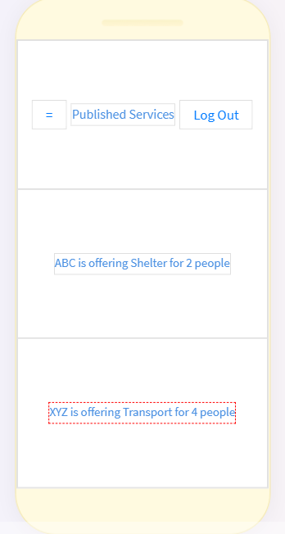

Payment Wallet:

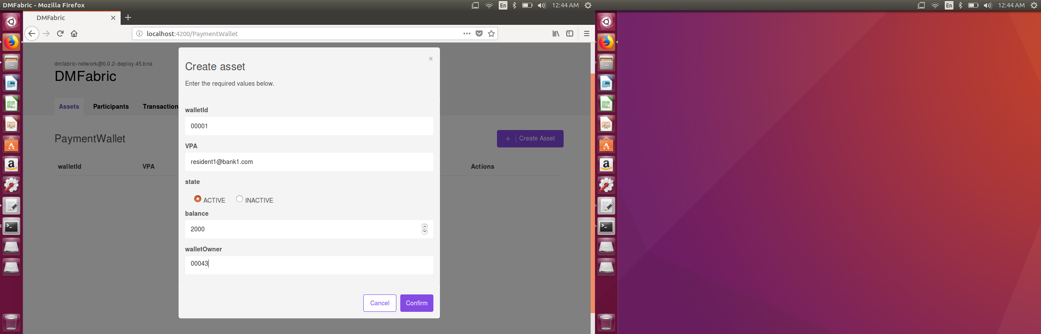

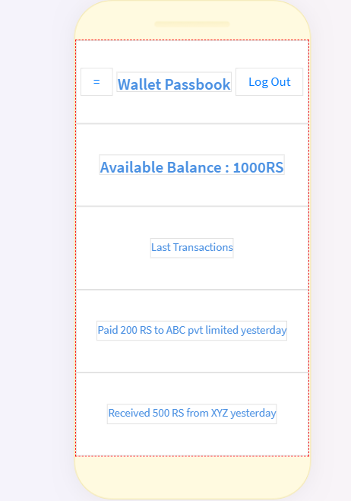

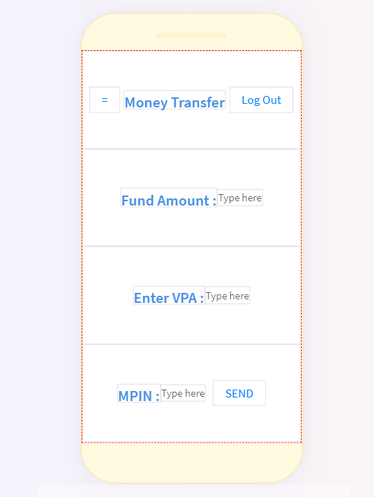

Detailed API flow and user interactions are covered in separate documents such as demo ppt. Video uploaded on Youtube channel - <https://www.youtube.com/watch?v=1fB7Y_VjOZ0> also covers user flow.

**What Next ?**

High level solution roadmap for DMFabric application can be like -

* Make necessary improvements in the DMFabric application and complete necessary integrations with different services to **make it PRODUCTION READY**
* **Integrate this Blockchain solution with IBM IoT Platform** –to leverage services for Internet of Things
* **Get this application to actual user base and communities to test** for feedback and inputs